**Report:**

The experiment is done for each data pool (2, 6 and 12 seconds).

The X axis is the number of iterations (1 to 20).

The Y axis is the accuracy.

The accuracy is calculated by the mean (averages) of 10,000 samples of the same iteration number (10,000 for 1 iteration, 10,000 for 2 iteration etc.).

Each sample result is calculated to be 1 if the majority is right, 0 if the majority is wrong and random 0/1 if it is a tie.

* Beginners (Pool of 2 seconds):

Samples Averages:

[0.649, 0.658, 0.724, 0.728, 0.766, 0.768, 0.811, 0.806, 0.841, 0.844, 0.862, 0.865, 0.878, 0.882, 0.899, 0.898, 0.913, 0.913, 0.925, 0.927]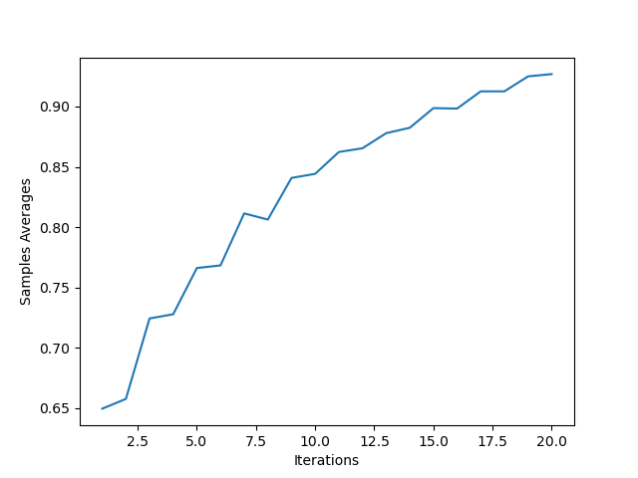

* Medium (Pool of 6 seconds):

Samples Averages:

[0.776, 0.777, 0.876, 0.873, 0.92, 0.928, 0.955, 0.956, 0.972, 0.974, 0.98, 0.981, 0.989, 0.987, 0.993, 0.993, 0.993, 0.995, 0.998, 0.998]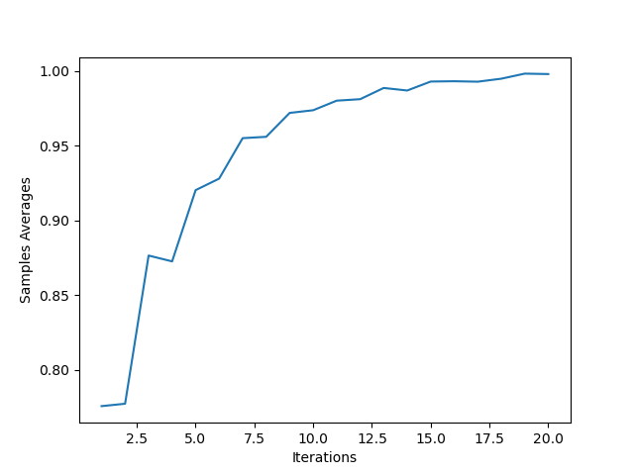

* Expert (Pool of 12 seconds):

Samples Averages:

[0.863, 0.866, 0.947, 0.951, 0.982, 0.983, 0.993, 0.991, 0.997, 0.996, 0.999, 0.999, 0.999, 0.999, 1.0, 1.0, 1.0, 1.0, 1.0, 1.0]